**Investigate success factors of the "****Employment Circuits" program of the Israeli Employment Service**

˚ Shalev Chen

_______________________________________________________

# **Abstract**

Unemployment is one of the most challenging tasks the world has ever faced, with 5.39% of the world population is unemployed for 2019 (3.8% of unemployment in Israel), before the Covid-19. Unemployment placements programs may reduce the unemployment length and reduce government expenditures on unemployment. This paper explores one of the Israeli Employment Service program data between 2016-2019, based on 56,000 jobseekers and 82 jobseekers' features (59% men and 41%women from age 18). The main results of this paper are: there is no difference between good placements of the Arabs population (49%) to any other populations (51%) like it was in 2018 (50.5% Arabs placements, 78% Jewish placements), the longer jobseeker stay in the program make his chance to return to labor market lower as he's being, there is some uncommon social-economic characteristic like education (academic degree and matriculation certificate has significantly found to be in amazing success), disability (no-disability is significantly found to be in medium success than other successes), religion (Jews and Muslims has significantly found to be in amazing success), number of kids(no matter how many kids the family/individual have, it's significantly found to be in amazing success than other successes), and others that affects the jobseeker placements and even increasing the number of jobseeker's activities adversely affects his chances of finding a job.

**Table of contents:**

**Abstract** 1

**1.** **Introduction**  3

**2.** **Background**  5

**3. Data Extraction and Factorize** 8

**4. Hypotheses, Success Definition, and Methodology** 11

Q1: Is there a difference between good placements of the Arabic population to other populations? 12

Q2: How long job seekers are in the program before their placements? 14

Q3: Is there a difference between the time length of jobseeker in the program to type of placement? 15

Q4: Do the number of activities from the program effects job seeker's placements? 17

Q5: Is there an effect between socio-economic jobseeker characteristics to placement? 20

**5. Conclusions** 22

**References** 23

# **Introduction**

Today unemployment is a global problem connected to various of social life fields which constitutes many research topics in various fields like economics, sociology, financial and more. Kabáta et al. (Kabáta, 2014) further describe there is no doubt that unemployment presents the biggest social problem in the EU [1]. Sol (Sol, 2016) states it turns out that in EU countries in general, a quarter of the unemployed who suffer from economic problems also suffer from health problems, alcohol addiction and/or discrimination [2]. The longer individuals are unemployed, the more they may lose their skills and become unemployable which is bad for the economy as well. On top of that, the problems associated with unemployment may result in unemployed being less healthy, which leads to health-related costs. Artazcoz et al. (2004) further described there is a tight relationship between unemployment and human health and mental health, and there are gender differences in the effects of family responsibility and social status [17]. Areas of high unemployment and social deprivation may also experience higher crime levels, suicide rates, and psychological problems. These will include loss of output to the economy, loss of tax revenue, reducing governments revenues to spend on public services, increase in government expenditure, etc. Zwinkels (Zwinkels 2015; Zwinkels & Guiaux 2015) fund that the chance of unemployed people returning to work decreases significantly once their allowance is confiscated. For the unemployed, the chance of returning to work decreases by 35% and the disabled by 12% and even concludes that unemployed persons with problematic debts do not find it more difficult to return to work than unemployed persons [3]. Research in Amsterdam, made by Koning, on social assistance shows that debt relief pathways in the context of employment services do lead to more placements, and placement without the relief paths may be relatively limited (Koning 2014) [5]. A research project among employment service providers in Europe indicates that as soon as unemployed debt improves (reducing), his chance of working tends to increase, which means debt controlling for unemployed people in need of social-political assistance will increase the chance of returning unemployed to the labor market (Sol & Kok 2014,p.144.p.168) [6]. Unemployment is considered one of the major risk factors for social exclusion. Exclusion from work can lead to social alienation, and in turn increase the risks of long-term social welfare dependency, suicide, becoming a criminal or a victim of crime, and political support for extremist parties. Furthermore, social exclusion may not only complement the current generation, but it will be passed on to the next generation (Polhan 2019) [18].

In Sweden, the unemployment rate stands on 6.5% and unemployment insurance combined with two components: general base insurance (base amount) and loss of income insurance (income-related benefit). Neither of the two components of unemployment insurance is examined by means. The base amount is available to a person who is or is not a member of the unemployment fund or who has not been a member for long enough. This means that only a person who pays a month for unemployment insurance will be entitled to a long period allowance to meet the conditions of the membership, which entails being a member of the fund or having been associated for at least one year without interruption. However, the applicant is required to fulfill the basic condition and working conditions for receiving a benefit in accordance with the base insurance (Gabriella) [8].

In Finland, the probabilities of long-term unemployment (unemployment > 12 months) were calculated for those aged 25-28 and found that 4.5% of women and 7.1% of men experienced or experienced long-term unemployment (out of 46,521) [15].

From the global situation examination (as of 27/11/2019), the State of Israel is ranked in the 10th place out of 36 OECD countries with a 3.8% unemployment rate in the OECD rate of unemployment before the Covid-19 spread all over the world and Israel is below the average of this OECD rate (5.2%). [26]

The Israeli Employment Service (IES) provides job placement and brokerage placements service to approximately 400,000 job seekers each year, through 60 employment bureaus deployed across the country. The IES has established several programs like 'Employment Circuits' (ES). These programs provide tools for placing job seekers in the labor market. This article will examine factors that influence the success of placement in the 'Employment Circuits' (ES) placement program in Israel which include approximately 60,000 job seekers.

# **Background**

Active labor market policies (ALMPs) are government programs that intervene in the labor market to help the unemployed find work. Many of these programs grew out of earlier public works projects, particularly those implemented under the 'New Deal' (The New Deal was a series of programs, public work projects, financial reforms, and regulations enacted by President Franklin D. Roosevelt in the United States between 1933 and 1939), designed to combat widespread unemployment in the developed world during the interwar period. There are three main categories of ALMP (i) Public employment services, such as job centers and labor exchanges, help the unemployed improve their job search effort by disseminating information on vacancies and by helping with interview skills and writing a curriculum vitae. (ii) Training schemes, such as classes and apprenticeships, help the unemployed improve their vocational skills and hence increase their employability. (iii) Employment subsidies, either in the public or private sector, directly create jobs for the unemployed. These are typically short-term measures that are designed to allow the unemployed to build up work experience and prevent skill atrophy.

The Portuguese programs aimed to help two target groups: (i) individuals aged less than 25 years (the Inserjovem program) and (ii) individuals aged 25 or more (the Reage program). Program participation is mandatory and who refuse to participate face a loss of entitlement to benefits and their registration is canceled. The programs are composed of intensive job-search assistance and small basic skills training, for example, writing a curriculum vitae. They include a large number of different responses by the employment office placement team. Each individual is interviewed with placement officers to help her/him improve job-search skills and, if deemed necessary, (s)he can enter a number of vocational or non-vocational training courses. The whole process of job-search assistance ends with the elaboration of a “Personal Employment Plan”, which includes detailed information on the unemployed individual's job-search effort. According to this Plan, the unemployed individual is expected to meet on a regular basis with the placement officer and to actively search for a job. Unjustified rejection of job offers leads to the cancellation of registration. [19]

In Europe, the European Employment Service (EURES) was established in 1994 and works in cooperation with all European countries in finding employment for European residents aged 18-35, where jobseekers can look for work in their own country and in another European in a free platform that enables job interviews via video call, help with moving to the country to which the job requires (residence and flight), language studies, conversion of relevant certificates and more. According to the EURES website (as of 12.12.2019), there are 2,191,759 jobs and 3,658,553 job seekers who apply for jobs. According to these numbers almost 60% can be applied for, but still there will be around 40% without job placement.  
Of course, not all jobseekers will be employee and these numbers are based only on the jobseekers registered for the system, for the jobs listed there. Therefore, I will refer to the figure of the OECD unemployment rate which stands on 6.3% in the EU unemployment.

In China, the unemployment index stands at 3.61% (2019) and in the early 1990, the Chinese government began its efforts to introduce labor market enforcement and standardization policies that strengthen and assist businesses in employees search, placement, and their adjustment. China has developed a strong information system infrastructure (The Hùkǒu System that is population registry system that contains all human information) in which jobseekers can help and assess their suitability for the roles they wish to enlist.  
In 1999, the Chinese government called to her all social sectors to adopt and use this system and pay attention to the school certificates and others that are in it to increase the ability and employment prospects.

The Japanese unemployment rate is 2.3% in the OECD. The starting point for unemployed in Japan is that they do not have the right to unemployment benefit or who have lost their eligibility, there is a very strong incentive to find work. In this specific situation, the Japanese Employment Service does not have to put a great deal of effort into running job placement programs because the unemployed have strong work incentives. As a result, these efforts in Japan, as measured by public spending efforts on placement policies, are relatively small. In 2011, Japan spent less than 0.3% of GDP (gross domestic product) on placement policies, less than half the OECD average (Martin 2014) [9].

Crost (2016) analyzed the effect of a type of workfare program, Germany’s "Arbeitsbeschaffungsmaßnahmen" (ABM), on life satisfaction. Previous studies have found evidence that participation in ABM reduces the probability of finding employment in regular jobs, at least for some groups (Hujer et al., 2004; Caliendo et al., 2008), so that the program’s long-term employment effects could offset the positive short-term effect on subjective well-being. Still, the current paper’s findings have important policy implications, suggesting that jobs created by active labor market policies can at least partly offset the negative effects of unemployment on subjective well-being [18].

Participation in active labor market programs (ALMPs) is mandatory for all unemployed persons in Denmark, who receive unemployment benefits, and who have been unemployed for more than 12 months. A large literature has analyzed the effect of ALMPs on the unemployed person’s reemployment probabilities and subsequent earnings, and hence of the probability that the programs prevent the unemployed from falling into poverty. [20]

The United States runs a considerable number of employment and training programs, spanning many government agencies. Although those run solely by United States Department of Labor (USDOL) are relatively small, the plethora of programs creates considerable administrative burdens for Public Employment Service (PES) staff. One of them is Job Training Partnership Act (JTPA). The goal of JTPA is to ensure that the types of training offered to job seekers reflect the needs of the local area. They must also meet detailed federal requirements on programs intake, encompassing criteria such as income and age. The programs appear well targeted on its intended groups. Evaluation evidence on the impact of the JTPA is decidedly mixed. Classroom training does not appear to help any target group, i.e. men, women, or youths. Although on-the-job training does appear effective for men, and particularly women, it only assists a relatively small number of individuals, and it is unlikely that it can be expanded greatly without some deleterious labor market effects setting in. Unfortunately, the reasons behind the overall lack of success for JTPA remain unclear. More research is clearly needed in this area to update these findings [22]. The statistical data on the "workers" seems to indicate that factors such as age, sex, race, lack of education and length of unemployment do not significantly affect placement rates [25].

Any program has her own pros and cons, some have succeeded more than others, and some has failed or not reach their accomplishment due to diverse causes. Without them, unemployment among society would be have greater impact the humanity. Winkelman's (Winkelman 2014) found that higher local unemployment has been shown to weaken the work ethic, so the regions that have higher crime/unemployment/job dissatisfaction relative to other places will have a greater impact on unemployment [7].

In January 2012, Israel's Central Bureau of Statistics (CBS) began conducting its Labor Force Survey under new guidelines. Among the Jewish population (men and women) the new survey did not result in a markedly different reported unemployment rate. In the Arab population, however, there was a dramatic hike in the unemployment figures: roughly doubling the previous rate among men and tripling it among women. This rise also implies an increase in the national unemployment rate [23]. A close look at the unemployment data reveals that unemployment is severe not only in the Arab and Jewish sectors overall but also in all the gender, age, education, and geographical groups. In groups that generally show high unemployment, the structural component of increased joblessness can be explained; but for Arabs, the data were just the opposite of what would be expected according to this argument: that is, despite the decline in the labor-force participation rate of groups with high unemployment, during the same period the average total unemployment rate increased. In recent years there has been a dramatic change in the sectoral (Jewish-Arab), gender, age, and education composition of the Israeli labor force (Miaari 2008) [24].

# **3. Data Extraction and Factorize**

The database containing 82 columns and 56,000 rows (each row presenting a jobseeker have joined the ES program and each column presenting a jobseeker characteristic like family status, religion, age, number of children, education etc.). The data was collected for the period from 2016-2019. The data is was analyzed to recognize empty cells or unsuitable cells for each characteristic, 14% of empty cells and 86% complete data.  
1860 unique activities categorized to 30 unique. Age column is categorized to groups of 18-29, 30-39, 40-49, 50-54, 55+. Education' column was divided into categories: elementary, high school, degree, professional certificate and no education. Religion column also divided into Jewish, Christian, Druze, Muslim or other. Country of Birth column has grouped to Judea and Samaria, Golan Heights, Gaza and Sinai. Disability Percentage column was divided into categories: [0,1), [1,20), [20, 40), [40,60), [60,100]. Language column has many options because each language has its own level, therefore, all extensions could be subtracted and left with only the name of the language. Licenses column has been converted from subdivision of categories into categories themselves. Family Status column were controversial (values such as: vacancy, polygamy, alliance, prescription) so they were converted to main: single, married, unknown including the regular of widow and divorced. Number of Children up to the age of 18 have been cataloged by: 0-7, 8+.  
Changing the "Activities that went through the program" column was must because when employees of the IES open a new activity, they can give free text to the program name and not choose one from a predefined list. Therefore, 1860 unique values were created and had to be filtered, categorized and creating predefined list of smaller and pre-agreed activities. After manipulating the data, only 30 unique activities were left. After these actions, all activities had to be deployed to indicate whether the jobseeker was in the same activity, if the jobseeker was in the activity receiving the value 1 and if not receiving value 0.

'Depth of unemployment in months' column values are from 0 to 100 were divided by 10 with the result rounded to get a categorical column. The age column is categorized according to what is used in the IES, groups of: 18-29, 30-39, 40-49, 50-54, 55+. The 'Education' column also has a lot of values that can be entered in free text, so it was divided into categories: elementary, high school, degree, professional certificate and no education. The "Religion" column is also divided into the major religions: Jewish, Christian, Druze, Muslim or other. Of course, each one contains several types and so it was decided to group them. Edge cases will not affect the data so be grouped to 'Other'. The 'country of birth' column has strange values that belong to Israel but appear as a different value from it: Judea and Samaria, Golan Heights, Gaza and Sinai. By logic thinking I decided to associate you with the value of 'Israel'. The 'Disability Percentage' column was divided into categories: [0,1), [1,20), [20, 40), [40,60), [60,100]. The 'Language' column has many options because each language has its own level. Therefore, it was decided that all extensions could be subtract and left with only the name of the language. The 'Licenses' column has been converted from subdivision of categories into categories themselves. Values in the 'family status' column were controversial (values such as: vacancy, polygam, alliance, prescription) so they were converted to main: single, married, unknown. Of course, there are also: widow, divorced. 'Number of children' up to the age of 18 have been cataloged by: 0-7, 8+.

***Table A.1 Socio-demographics features***

|  |  |  |  |  |  |  |
| --- | --- | --- | --- | --- | --- | --- |
| **Socio-demographics features** | | |  | **Number of Job Seekers** |  | **Weight (%)** |
| **Gender** |  | Male |  | 22,765 |  | 41% |
|  |  | Female |  | 33,224 |  | 59% |
|  |  |  |  |  |  |  |
| **Age** |  | 18-29 |  | 9,192 |  | 16% |
|  |  | 30-39 |  | 15,213 |  | 27% |
|  |  | 40-49 |  | 19,304 |  | 34% |
|  |  | 50-54 |  | 8,386 |  | 15% |
|  |  | 55+ |  | 3,894 |  | 7% |
|  |  |  |  |  |  |  |
| **Religion** |  | Jews |  | 23,887 |  | 43% |
|  |  | Muslims |  | 25,876 |  | 46% |
|  |  | Druze |  | 1,761 |  | 3% |
|  |  | Christianity |  | 1,361 |  | 2% |
|  |  | Other |  | 3,102 |  | 6% |
|  |  | No Religion |  | 2 |  | 0% |
|  |  |  |  |  |  |  |
| **Singel Parent** |  | Yes |  | 5,880 |  | 11% |
|  |  | No |  | 50,109 |  | 89% |
|  |  |  |  |  |  |  |
| **Education** |  | Primary School |  | 11,140 |  | 20% |
|  |  | Part Secondary school |  | 10,650 |  | 19% |
|  |  | Secondary school |  | 25,467 |  | 45% |
|  |  | Bagrut certificate |  | 2,436 |  | 4% |
|  |  | First Degree |  | 1,943 |  | 3% |
|  |  | Second Degree |  | 732 |  | 1% |
|  |  | Third Degree |  | 68 |  | 0% |
|  |  | Associate degree |  | 1,372 |  | 2% |
|  |  | License |  | 10 |  | 0% |
|  |  | No Education |  | 2,171 |  | 4% |
|  |  |  |  |  |  |  |
| **Disability** |  | None |  | 50,825 |  | 91% |
|  |  | 1% to 19% |  | 657 |  | 1% |
|  |  | 20% to 39% |  | 1,966 |  | 4% |
|  |  | 40% to 59% |  | 1,372 |  | 2% |
|  |  | 60% to 100% |  | 1,169 |  | 2% |
|  |  |  |  |  |  |  |
| **Family Status** |  | Single |  | 17,205 |  | 31% |
|  |  | Married |  | 25,117 |  | 45% |
|  |  | Divorced |  | 11,840 |  | 21% |
|  |  | Widow |  | 1,511 |  | 3% |
|  |  | Unknown |  | 316 |  | 1% |
|  |  |  |  |  |  |  |
| **Number of kids under 18** |  | None |  | 22,400 |  | 40% |
|  |  | 1 to 3 |  | 23,428 |  | 42% |
|  |  | 4 to 6 |  | 8,367 |  | 15% |
|  |  | 7+ |  | 1,794 |  | 3% |
|  |  |  |  |  |  |  |
| **Military Service / Sherut Leumi** |  | None |  | 45,752 |  | 82% |
|  |  | Sherut Leumi |  | 941 |  | 2% |
|  |  | Military Service |  | 9,296 |  | 17% |
|  |  |  |  |  |  |  |
| **Unemployment duration** |  | <1 year |  | 4,519 |  | 8% |
|  |  | 2 - 3 years |  | 5,166 |  | 9% |
|  |  | 3> years |  | 46,100 |  | 82% |
|  |  | None |  | 204 |  | 0% |

# **4. Hypotheses, Success Definition, and Methodology**

The goal needed to be defined by which could be investigated and analyze the research questions using the data. The fact that the concept of "success" was interpreted differently in each situation, for research purpose the success index was divided into 4 categories, each category named as label:

1. Amazing Success:

No revolving door cases, placement since enters the program = 1, no resumption date.

1. Medium Success:  
   No revolving door cases, placement since enters the program > 1, no renew activity date, or no renew registration date.
2. Weak Success:

All job seekers who not in label 1,2 or 4.

1. Failure:

No resumption date, no placements since joining the program, or revolving door cases higher than 0.

Research questions:

(Q1) Is there a difference between good placements of the Arabic population to other populations?

(Q2) How long job seekers are in the program before their placements?

(Q3) Is there a difference between the time length of jobseeker in the program to type of placement?

(Q4) Do the number of activities from the program effects job seeker's placements?

(Q5) Is there an effect between socio-economic jobseeker characteristics to placement?

## **Q1: Is there a difference between good placements of the Arabic population to other populations?**

In 2015, the percent of labor market employment in the Arabs community was 54.6% and 81.7% in the Jews community [28]. The number of unemployed Arabs is larger and requires action. Israeli government makes affirmative actions to Arabic people and gives funds for employment places to grow, a fund for education (scholarships, reduced taxes, etc), and more. There are many reasons for affirmative actions like cultural differences, traditions, geographical environment, social status, and more In the IES they have government funds (1.2 million NIS) for a specific program called "Tapuah" (the program gives 1.466 million NIS) [29] specific organized for Arab people, but there is no evidence that will justify open special programs to their community at this program expense, or at least show that 'Employment Circuits' has a negative or non-effect for Arabs. The hypothesis that there is no difference in their placement in the 'Employment Circuits' program will be examined with $∝=0.05$.

$$diff=\left[\left(is_{arab}=0\right).POGP-\left(is_{arab}=1\right).POGP\right] \\ * POGP=propotion of good placing$$

There is a need to see if the data is distributed of normal distribution. Therefore, we need at least 30 bureaus where the number of Arabs will be a statistical basis for the hypothesis (at least 14 Arab jobseekers in the bureau needed to reach a state with 30 unique bureaus). A comparison was made between the Arabs with good placement and the non-Arabs with a good placement from the same bureau. The 'diff' column was calculated, and it's representing the differences in good placing proportion to estimate the differences in placements in the same bureau. There is a need to check if the differences are normally distributed, the histogram will show the number of samples relative to the difference and by a density function.

Figure 6.1.3 Histogram of 'diff' column

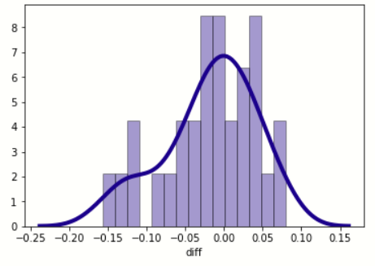

(The X-axis shows the differences and the Y-axis shows the number of samples.  
The estimate of variance $S^{2}$ is 0.0035).

It seems from the data that the density function (blue line) does imply that the data is a normal distribution (obviously this is not enough, and a statistical test will be performed below).

Figure 6.1.4 Comparing CDFs for KS-Test

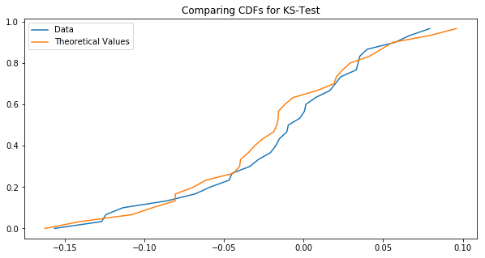

After comparing CDFs for KS-Test, it seems there is a very large resemblance to a normal distribution, so to verify that the good placement differences are distributed normally Kolmogorov Smirnov test was made via SPSS to confirm.

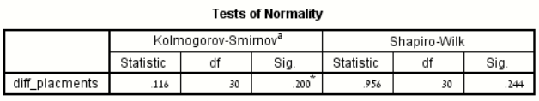Figure 6.1.5 Kolmogorov-Smirnov Test

Kolmogorov Smirnov test results show ρ (the critical value) is greater than ∝ so we say the diff column is normally distributed. since we have 30 samples and we saw that the data is normally distributed we can use a t-test to examine the difference between dependent pairs (30 bureaus out of 60 bureaus). It is assumed that there are more similar characteristics to populations from the same bureaus.   
  
The expected value estimator is: $\overline{D}= \frac{1}{n}\sum{X-Y}$ and the result is -0.018. Calculation of our statistic: $t= \frac{\overline{D}}{\sqrt{\frac{S^{2}}{n}}}$ and its results are -1.686.  
Therefore, T-test result is: t (0.95,29) = 1.699, $ρ=0.097$, $∝=0.05$.

The conclusion is to reject the null hypothesis and say there is no significant difference between the placement of the Arabs and the placement of the non-Arabs.

## **Q2: How long job seekers are in the program before their placements?**

To answer this question, a copy of the data was made into a new file and transfer to the data frame with the columns of "Last Placement Date", "Last Placement Report Date", " Initial Entry Date". Some data have blank dates ("NAT"). To understand how long the jobseekers in the program, a calculation was made in the 'day_diff' column.

$$d{f_{entry}}_{dates}.loc\left[:,'days_diff'\right]=df[LPD]-d{f_{entry}}_{dates}[FJTPD] \\ * LPD=last placement date^{'}$$

$$* FJTPD=first joining to the program date$$

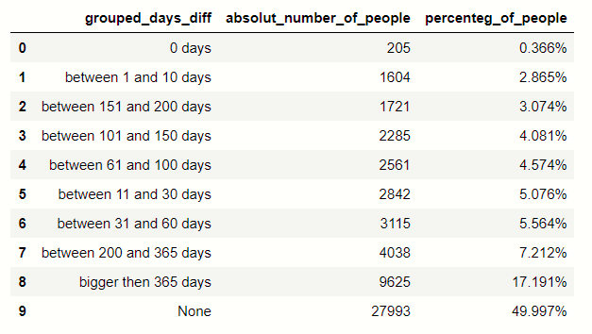Figure 6.2.1 'Days_Diff' division to categories

Almost half (49.99%) of program participants do not have a "placement date" and more than 25% have "first entry date" greater than "last placement date". After clearing the records of the negative diff, the data were summarized. Confidence interval is: (Left: [336.994], Mean: 341.418, Right: [345.8417])

## **Q3: Is there a difference between the time length of jobseeker in the program to type of placement?**

A continued question to the previous result, is there a difference between the time length of jobseeker in the program to type of there placements? Is longer attended to this program give more tools to jobseeker to find a job, but is this the reality? And if it is, a longer stay needs to return a better placement. Another hypothesis is there is a difference between the time of job seekers in the program to the type of their placements, the examination will be examined with $∝=0.05.$ Figure 6.3.1 shows the division of different labels and the length of their being in the program.

Figure 6.3.1 Time of jobseeker in the program division by label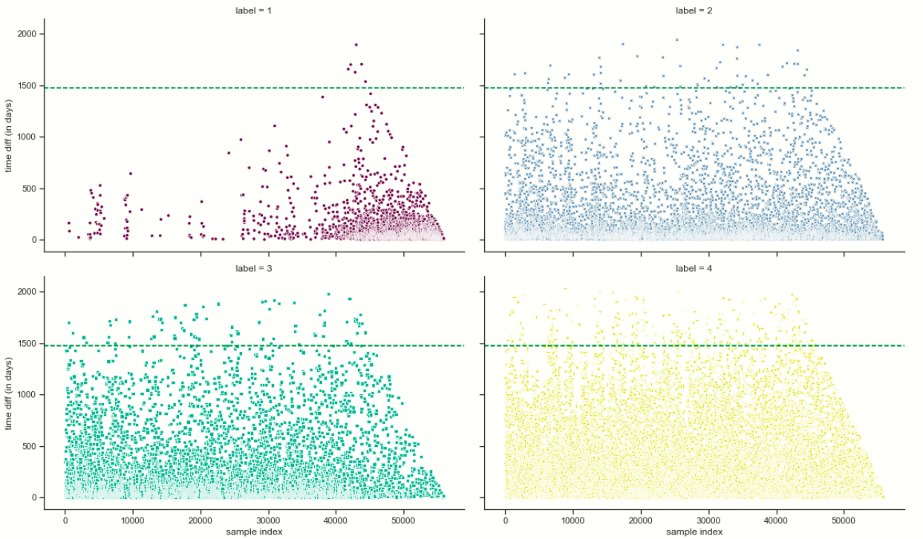

From the graphs, it seems that better label has a shorter time frame in the program (vice versa to the thought of longer stay need to return a better placement). But it is not enough just in the graph of the data to conclude this, a statistical test must be performed to verify it.

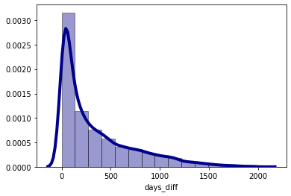

To test if the data is normally distributed, the Kolmogorov Smirnov test was made and the result of ρ is ~0.0, therefore, we do not reject the null hypothesis.

|  |  |  |  |
| --- | --- | --- | --- |
| **Tests of Normality** | | | |
|  | Kolmogorov-Smirnova | | |
| Statistic | df | Sig. |
| days_diff | .183 | 27996 | .000 |
| a. Lilliefors Significance Correction | | | |

To check the difference between the day's differences between the different labels an ANOVA test was done, and its results are within label there is a difference between the different label groups. To know which label has a difference with another, a Tukey post hoc test was made to test time differences between each label pair separately.

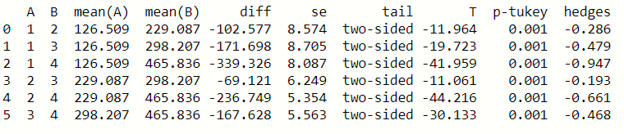Figure 6.3.3 Tukey Post Hoc Test

Clearly, we can say confidently that between all the means pairs exist differences such that the means declares with the decrease of the labels, and this is based on the two test results that were hypothesized.

## **Q4:** **Do the number of activities from the program effects job seeker's placements?**

Only 30 unique activities defined in the data frame. It was necessary to change the "Activities in the program" column to a categorical variable and layout the activity in a new column and to provide a binary classification if the job seeker was in the activity = 1 if not 0.

Checking the hypothesis that more activities job seekers will anticipate cause decreasing labels for job seekers.

Figure 6.4.1 Number of programs per label

After these actions, the sum of all activities in which the label was assigned would be summed and see the percentage of all activities.

Figure 6.4.2 Sum and percent of jobseekers from each label and activity

|  |  |  |  |  |  |  |  |
| --- | --- | --- | --- | --- | --- | --- | --- |
| Label | Change course | Process course | Occupational Hebrew course | Computer application course | Personal training | … | Number of programs |
| **1** | 131 | 3 | 42 | 0 | 1231 |  | 2457 |
| **2** | 507 | 10 | 133 | 1 | 4200 |  | 8643 |
| **3** | 395 | 7 | 72 | 0 | 3786 |  | 7435 |
| **4** | 2550 | 60 | 674 | 14 | 23151 |  | 48900 |
| **Label 1 Fraction** | 4% | 4% | 5% | 0 | 4% |  | 4% |
| **Label 2 Fraction** | 14% | 12% | 14% | 7% | 13% |  | 13% |
| **Label 3 Fraction** | 11% | 9% | 8% | 0% | 12% |  | 11% |
| **Label 4 Fraction** | 71% | 75% | 73% | 93% | 72% |  | 73% |

According to the table above, anyone with label 1 seems to greatly reduce their number of activities in general and in each activity from any other label. It was necessary to see if there was a significant difference in the variance between activities in the program with the ANOVA test, but first to check if the data is normally distributed. Kolmogorov Smirnov test showed significant results with each number of programs per label, therefore, ANOVA test was performed and the $ρ$ of ANOVA is ~0 which means its significantly shown that it is different between different activities and the time when job seekers are on the program. It was necessary to continue investigating the difference between activities using the Tukey Post Hoc test.

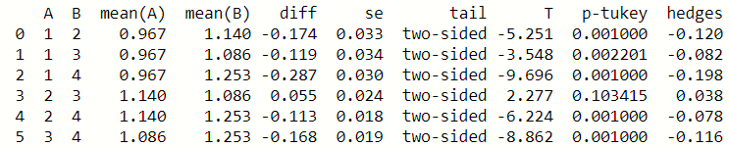Figure 6.4.4 Tukey Post Hoc test

There is a difference in the number of activities between the different types of successes (label), except for groups 2 and 3.

After exploring all the different activities as individuals, a decision tree model that would take a sample of jobseekers and match their socioeconomic characteristics and activities against the data frame from which it was sampled will be helpful to see it graphicly. The model models jobseekers and presents the most definite trajectory for him according to the jobseekers he resembles, both in terms of their programs and in terms of socioeconomic characteristics. The decision to use the decision tree is because it shows the most recommended route (order of action). There are many other models for this kind of decision, but after considering alternatives it was decided that this model would be best for the given situation. The model shows the most definite trajectory, so the tree should be considered as the order of best practice for those sampled job seekers. Of course, the tree is no definite promise that according to the proposed route, job seekers will be implemented in this way.

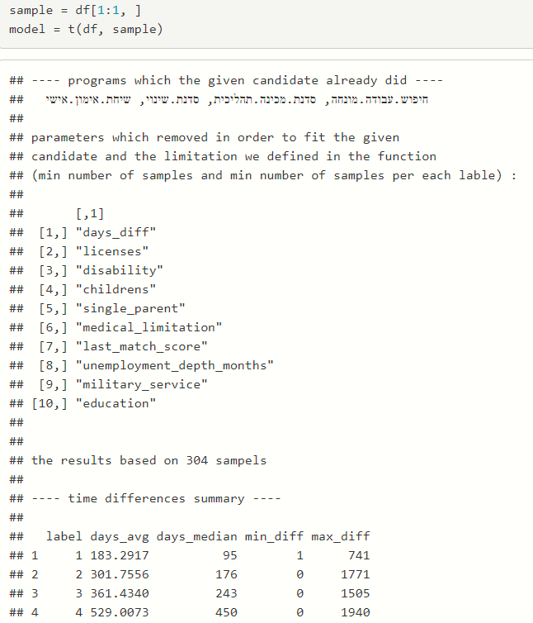

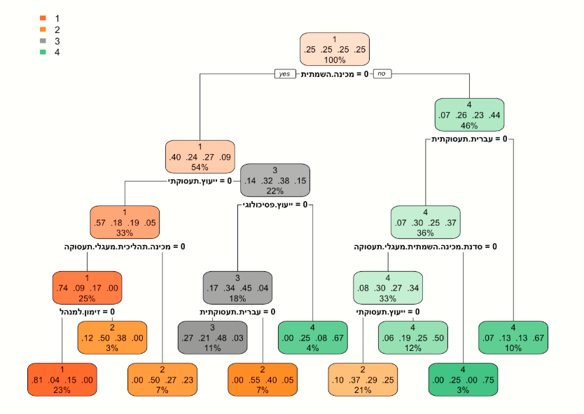

## **Q5: Is there an effect between socio-economic jobseeker characteristics to placement?**

This question is to see if there is a socioeconomic characteristic that affects the placement more than other characteristics. The definition of socioeconomic characteristics of jobseekers is religion, age, single parent, gender, level of education, city, language, country of birth, marital status, children up to age 18, classification of the jobseeker, disability rates, medical disability, licenses, military service, released prisoner and month of placement ("last placement date"). Building a new data frame that consists of these columns and sorted the data into them. Uniting religions into major religions: Jewish, Christian, Muslim, and Druze, otherwise, it will have value: another. Level of education was categorized into major: elementary, high school, degree, and professional certificate. Ages were grouped according to the employment service practice: 15-29, 30-39, 40-49, 50-54, 55+. In the 'Land of Birth' column, there are several places in Israel that were divided: Israel, Judea, and Samaria, Golan Heights. Any country of birth with less than 1% frequency dropped from the data because they are end-cases that will not affect the results below. Using a multinomial regression model comparing the model with all variables to the cutter model only. This model is recognized in research methods as in the research of Xiaoye Zhang, Yiping Tian, Mindong Bai, Zhitao Zhang [11].   
McFadden's formula, subtracting from the estimate log distribution from 1, therefore, the higher the resulting value (between 0 and 1) the more pronounced the model is.

$$R^{2}McFadden=1-\frac{log⁡(L_{c})}{log⁡(L_{null})}$$

It is important to understand that multinomial multivariate regression makes it difficult to reach a result close to 1 because very strong explanatory parameters are needed to increase the value of McFadden's estimate. In attempting to play with the model and to interplay variables and remove irrelevant variables, no more statistically significant result was obtained than the full model. In the case of my data, the McFadden estimate is 0.239. According to McFadden [12], the estimate for a good fit model is between 0.2 and 0.4, so it can be said to be statistically significant and that there is a correlation between the socioeconomic variables and the type of placement. The variables presented by the model are more likely to influence the placement result (which type of label is jobseeker).

Some of the model results can be present as commonsense thinking, but some can surprise us all. All model results are compared to label 4 (failure) and each model result was displayed is significant (ρ < 0.05).

1. There are more Arab cities compered to Jewish cities in labels 1 and 2.  
   Muslim and Jew religions significantly more to be in label 1.  
   All that supporting question 1 results and conclusion.
2. Some country origin effects on program success, like the Soviet Union and France significantly more to be in label 3 than label 1 (compered by p-value).  
   Ethiopia significantly more to be in label 2.
3. Education has a strong effect on the success label. Academic degree or 'Teudat Bagrut' has significantly more to be in label 1, and non-education significantly more to be in label 3.
4. Disability affects human life including program success. From 20%-59% significantly more to be in label 2 and 60%-100% to be in label 3, but no disability at all significantly more to be in label 2 and not 1 as we expected.

# **5. Conclusions**

The proposed research aimed to examine the success factors of the Israeli Employment Service (IES) 'Employment Circuits' program. There is no difference between the placement of the Arabs and the placement of the non-Arabs. Number of jobseekers how have placed through the program is 50% which indicated on low rate of placements, furthermore, the average length attending the program before placement is 341 days. Following to the finding, it is proven that longer the jobseeker being in the program, the quality of his placement (label) decreasing. Subsequently, a decision tree model was established to assess affect between program activities to jobseekers' placements and it has supported the result of previous finding. The multinomial regression model was established to assess the relationship between unemployment to job seeker’s socioeconomic characteristic (religion, age, single parent, gender, level of education, city, language, country of birth, marital status, children up to age 18, classification of jobseeker, disability rates, medical disability, licenses, military service, released prisoner and month of placement) to job seekers placements. By logic and/or social norms, those with a degree should be more successful than those with only a high school diploma or no education. There are 10 Arab cities compared to 5 Jewish cities in label 1. There is a direct relationship between the number of children and signal parents. It is possible to guess or investigate the direction of the placement month that may indicate periodic unemployment. It will be harder to succeed for those with a higher disability, or a divorced marital status (alimony). There are 3 Arab cities as opposed to 4 Jews in label 2. If you are of Ethiopian origin, there is a greater chance of success than those of the Soviet Union or France to be in label 2. Those who do not have any education should be less successful/not successful than those with an education. Even with regard to severe medical disability, it is understandable that the more severe the medical disability, the less likely to be placed because there are limitations to the person in his job.

# **References**

1. Ladislav Kabáta, David Hampelb, Ladislava Issever Grochováb, Jitka Janováb, Luboš Střelecb, "Alternative approaches for assessing the European countries economic and social results". *17th International Conference Enterprise and Competitive Environment 2014* Volume 12, Pages 1-804 (2014).
2. Els Sol C.C.A.M. (2016). Getting unemployed with problematic debt problems to work. A quick scan of debt helps strategies by European Public Employment Services. Universiteit van Amsterdam, AIAS Working Paper 167.
3. Zwinkels, W. en Guiaux, M. (2015) "Schulden belemmeren terugkeer naar werk" ESB, 1000 (4722),690-92.
4. Zwinkels, W. (2015), "Wie heeft schuld? Een kwantitatieve analyse van schulden bij uitkeringsgerechtigden". Amsterdam:UWV.
5. Koning, P. (2014) "Door schuldhulpverlening uit de bijstand". *ESB* jrg 99 (4677), 38-41.
6. Sol, C.C.A.M. & K. Kok (2014) *Fit or Unfit: Theorie en praktijk van Re-integratie*. Amsterdam: RVO.

1. [Rainer Winkelmann](https://wol.iza.org/authors/rainer-winkelmann), "Unemployment and happiness". *doi: 10.15185/izawol.94* October 2014.
2. Gabriella Sjögren Lindquist, "Unemployment insurance, social assistance and activation policy in Sweden", *Implementierung the news basic allowance for job seekers, Berlin.* 17-18 April 2007 [https://www.researchgate.net/profile/Gabriella_Lindquist/publications 13 April 2015](https://www.researchgate.net/profile/Gabriella_Lindquist/publications%2013%20April%202015).
3. John P. Martin " Activation and Active Labour Market Policiesin OECD Countries- Stylized Facts andEvidence on their Effectiveness", *Geary Institute, University College Dublin and IZA*, 2014.
4. International Labour Organization (ILO) Resolutions Concerning Economically Active Population, Employment, Unemployment and Underemployment Adopted by the 13th International Conference of Labour Statisticians, October 1982, para. 10
5. Xiaoye Zhang, Yiping Tian, Xiaofang Zhang, Mindong Bai, Zhitao Zhang, "Use of multiple regression models for predicting the formation of bromoform and dibromochloromethane during ballast water treatment based on an advanced oxidation process", 4 August 2019.
6. Daniel McFadden, "Quantitavie methods for analyzing travel behavior of individuals: some recent developments", November 2, 1977.
7. צמצום פערים חברתיים כלכליים ופיתוח כלכלי במזרח ירושלים | מספר החלטה 3790 | משרד ראש הממשלה.
8. פעולות המדינה לעידוד שילובה של האוכלוסייה הערבית בתעסוקה, דוח שנתי 66ג, התשע"ו 2016.
9. Tea Lallukka, Martta Kerkelä, Tiina Ristikari, Marko Merikukkac, Heikki Hiilamo, Marianna Virtanen, Simon Øverland, Mika Gissler, Jaana I. Halonen, "Determinants of long-term unemployment in early adulthood: A Finnish birth cohort study", Volume 8, August 2019, 100410.
10. Pohlan, “Unemployment and social exclusion”, Volume 164, August 2019, Pages 273-299.
11. Lucía Artazcoz, MPH, Joan Benach, PhD, Carme Borrell, PhD, and Immaculada Cortès, MPH, "Unemployment and Mental Health: Understanding the Interactions Among Gender, Family Roles, and Social Class", *American Journal of Public Health* January 2004, Vol 94, No. 1
12. Benjamin Crost, *"*Can workfare programs offset the negative effect of unemployment on subjective well-being?", *Economics Letters*, Volume 140, March 2016, Pages 42-47.
13. Luis Centeno, Mário Centeno, Álvaro A. Novo, "Evaluating job-search programs for old and young individuals: Heterogeneous impact on unemployment duration", *Labour Economics 16, (2009) 12–25.*
14. Signe Hald Andersen, "Exiting unemployment: How do program effects depend on individual coping strategies?", *Journal of Economic Psychology 32*, (2011) 248–258.
15. Yan DI, "China’s Employment Policies and Strategies", *Chinese Academy of Labour and Social Security, Ministry of Labour and Social Security, P.R.China.*
16. Head of Publications Service, OECD Publications Service, *"The Public Employment Service in The United States"*, *2000.*
17. Taub Center Staff, *"Arab Israeli Unemployment Much Higher than Previously Thought"*, Bulletin Articles, December 02, 2012
18. Sami Miaari, *"The Dynamics of Unemployment among the Arabs in Israel: Evidence from Panel Data",* October 2008.
19. United States. Congress. House. Committee on Education and Labor. Subcommittee on Employment Opportunities, "*Welfare jobs legislation: hearing before the Subcommittee on Employment Opportunities of the Committee on Education and Labor, House of Representatives; Ninety-sixth Congress, first[-second] session, on H.R. 4425 ... H.R. 4426,* 1979-1980, page 66-67.
20. The Unemployment Rate by the OECD: https://data.oecd.org/unemp/unemployment-rate.htm